

This document has been approved.

Restructuring of our organisation

How it can help us

**Next review due:** No future review.

**Published by:** Sustainable Transport Holdings

**Written by:** Harry Burr, on behalf of Sustainable Transport Holdings

Contents:

1. Our previous structure
   1. Too many layers
   2. Complicated
   3. Local Revamp England
   4. Spark
2. SwipeSpark
   1. Why we thought it would be better
   2. Why it was not better
   3. Adding new unnecessary layers
3. Brand
   1. It just makes sense to rebrand
   2. Logos
   3. Simplicity
   4. Colour
   5. Font
4. Domain structure
   1. Primary domains
   2. Secondary domains
   3. crd.co domains (tertiary domains)
   4. Unused domains: The plan
5. Other organisation changes
   1. Transport for South Midlands
   2. A new for-profit organisation
   3. TfSM Tram

# 1. Our previous structure

## Too many layers

Although advised to add more layers to save time, money, and stress, it became *too* much. At one point, we had 4 different organisation layers in some places, with primary, secondary, tertiary, and quaternary organisations, and a mix of for-profit and not-for-profit made it even more difficult to manage, especially with tax having to be paid for one part of the business, and a different amount for another. It made everything excruciatingly difficult.

## Complicated

Our old structure was too complicated, time wasting, and stripped us of almost all our money, although advised it would *save* money. It was clear we needed to change. By changing, we can simplify our operations, for-profit and not-for-profit, and save money, although expected we would save money by creating *more* layers, not less.

## Local Revamp England

When we made the choice to restructure again, due to all the benefits, we had a few costs too. This included dissolved Local Revamp England, with tertiary organisations such as Local Council Reorganisation Campaign, New Cities Campaign, and Urban Conversion Campaign. Throughout these tertiary organisations, only one quaternary organisation was actively operating, Weedon Riverside Garden Village project. All this project achieved is a report, no contact with local stakeholders/councils, unfortunately.

## Spark

As well as this, our only for-profit company, Spark, had to go too. It had no tertiary organisations, so did not operate in its entire lifespan. It was a placeholder for eventual for-profit projects. In future, I would like to set up a separate company from Sustainable Transport Holdings which allows me to subsidise STH’s not-for-profit operations.

# 2. SwipeSpark

## Why we thought it would be better

We made major structural changes, because we thought it would be more straightforward, for me (Harry Burr) especially. SwipeSpark would have operated as my accounts/management company. Instead, it did this task for about a week before this document came into force. It did not help in any way, it instead just wasted money and gave me more headaches, which it was made to avoid. We thought it would help due to being more straightforward to set up accounts, allowing them to be set up under SwipeSpark’s name, and being eligible to operate throughout all of SS’s secondary, tertiary, and quaternary operators. It turns out there was not much point of this at all, as most of our accounts covered *secondary* operators/brands, instead of *all* P, S, T and Q.

## Why it was not better

Now going onto why it did not work. As I started to say, most of our existing core accounts were already registered under our secondary operators, so it would have cost us a lot of money, time, effort etc to move them all under our primary operator, SwipeSpark, instead. There was no point an umbrella existing. Yes, it did try to simplify, but failed, due to our existing accounts we would have to transfer. To this day, most of our accounts are under Sustainable Transport Holdings, or separate accounts for Northamptonshire and Outer Regions secondary operators.

## Adding new unnecessary layers

SwipeSpark was this unnecessary layer. The first layer was SwipeSpark, the primary operator. Underneath SwipeSpark was Sustainable Transport Holdings, Local Revamp England, and Spark. Spark was the only one of our secondary operators that did not have any quaternary operators. In fact, it did have tertiary operators in mind, but these projects were cancelled after this document was published.

Local Revamp England had tertiary and one quaternary operator, and Sustainable Transport Holdings was the largest secondary operator, having 2 tertiary operators, and 5 quaternary operators. The layer was supposed to look like a triangle, more operators the larger the number got, e.g., 1 primary, 2 secondary, 3 tertiary, 5 quaternary. It turned out to not look like this, which was a big failure for SwipeSpark. These proposed plans fixes this.

# 3. Brand

## It just makes sense to rebrand

The organisation is undergoing major changes, it just makes sense to rebrand along with it. There is no better time, and our logos are starting to look a little dated, and when someone looks at our logos, they think: SwipeSpark. This is not what we want them to do. We want them to think: Transport. This is half of what our new brand is about, letting the customer know this is a fresh, new start.

## Logos

So, here are the logos we came up with. Although now published on most of our media locations, such as websites, social media profiles, letterheads, PowerPoints etc. it is yet to be approved by administration. Here they are:

These logos show our not-for-profit nature, care to the environment, and transport heritage. They also show that we are a modern organisation, and ready for future modernisation.

As you can see, these four logos are remarkably similar, but this is a good thing. It shows that we are interlinked, and work together all the time, for a better future.

It also helps differentiate which organisation has “the most power”, with Holdings having a separate icon design to Sustainable Transport’s and the TfSM logos

## Simplicity

This brings us well onto the simplicity of our new brand. If you look at our logos, one of the main things you will think is, woah, that looks simple, minimalist, and modern. That is what we want you to think, as that also projects our new brand image. A simpler corporate structure for our not-for-profits.

## Colour

This makes us sound terribly gloomy, grey, and dark, but we do not like colour. To keep to our clean, modern, simplistic brand image, we do not use colour in our logos. Occasionally we will, and we have built a colour palette around that, but we advise people to not use colour in our logos unless required and there is no other option.

We like gradients, not solid colour, if ever we need to use colour. In our maps and website headers for example, we are always sure to never use a solid colour, instead taking two colours and making a gradient out of them. On our website headers, we take a grey and a black, and create a linear gradient. On our maps, for lines, we have no choice but to use solid colour unfortunately, but we will try to incorporate gradients where solid colour does not have to be used.

## Font

As well as our new logos and colour system, we have revamped the fonts we use on documents, logos, and websites. Inter remains our primary font for large economic analysis’s, reports, and whitepapers, but for smaller reports like this, Open Sans is our new standard font. In our logo, we are using Helvetica Neue, but we suggest this never to be used anywhere apart from our logo.

In emails, especially via Google Gmail, we will be standardising Arial Italic, Regular, and Bold, however, we do have guidelines as to where to use these three different variants of Arial, visible above in our official recommended FBG.

# 4. Domain structure

## Primary domains

Along with our new organisation structure, we have also restructured our domains into two different categories. Starting off, we have Primary Domains, used by Holdings, and most of our internal services, such as the following

* Transport.click
* Service.swipespark.digital

We do not have many primary domains; however, they are our most important type of domain, being the backbone of the entire organisation, especially through email.

## Secondary domains

Our secondary domains, however, are domains that come under our secondary operators, including TfSM and Sustainable Transport tertiary operators. These include:

* Transport-northants.com
* Transport-mids.com
* TfSM.click

Our secondary domains are 100% our most important domains, handling most of our web traffic, email, and are the most commonly used domains for subdomains and web hosting.

## Crd.co domains (tertiary)

You may have seen our crd.co domains. We normally refer to them as our tertiary domains. They are the backbone for our tertiary organisations. They are normally subdomains of the crd.co domain, owned by our hosting provider. However, a small amount of our tertiary domains are owned by us. These include:

**Crd.co**

* SNL.crd.co
* BAN-WOL.crd.co
* Tarka.crd.co

**Owned by us**

* Weedonstation.site

Our owned domains are rare and are not normally used, in an attempt to simplify our domain structure even more.

## Unused domains: The plan

Of course, after the plans this document details is approved, we will have a load of domains that are useless. These include:

* LocalRevamp.xyz
* SwipeSpark.digital (MASTER ONLY)

By master only, I mean the primary domain only. SwipeSpark.digital is still being used as a subdomain for our services, however, we plan to transfer off of SwipeSpark’s domain, in favour of transport.click soon. LocalRevamp.xyz has no plans and will probably be used as a sandbox/testing domain until its renewal comes up, where we will terminate its contract.

# 5. Other organisation changes

## Transport for South Midlands

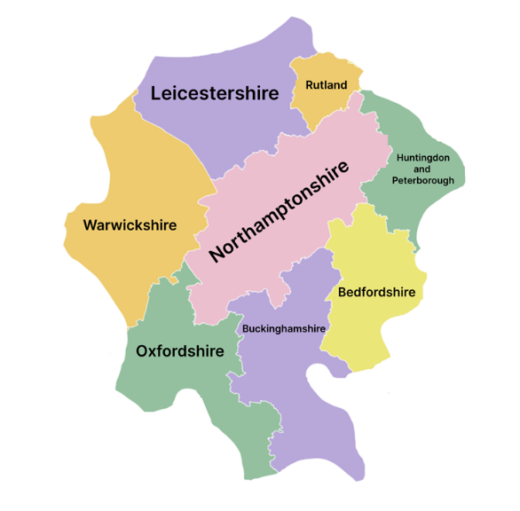As you have seen in parts of this document, a new organisation you probably have never heard of is being developed (upon approval of this document), called Transport for South Midlands. It will essentially act as a consortium/group of local councils and some stakeholders, with a goal to improve transport in the South Midlands (aka, this area). We will be inviting new members in this priority list:

1. Parish/town councils
2. Other stakeholders e.g large local businesses
3. Sub-national transport bodies
4. Transport operators (bus, rail, tram etc.)
5. District councils
6. County councils
7. Unitary councils (and CAs)
8. Government departments

This priority list ensures that further down the line, the Government and unitaries (and CAs) especially will be inclined to join us due to our existing following. It will be easier to attract local businesses and parish/town councils. This approach allows us to work our way up the food chain of sorts!

## A new for-profit organisation

To ensure our not-for-profit organisations can continue operating and invest in more services to benefit the local people, we need a for-profit organisation, sending all its profit directly to Sustainable Transport Holdings, where it will be spent responsibly. The problem with this plan is what exactly we will do to make money for this for-profit company. This is yet to be figured out, but I will be forming a new document when this new organisation is finalised. Hint: It will probably use the old SwipeSpark brand and digital components, e.g., domain.

## TfSM Tram

A relatively new tertiary operator campaign of ours, TfSM tram, has had to be paused temporarily (Under Sustainable Transport Northamptonshire) due to COVID, other projects we need to dedicate time on, among other things. We hope to get TfSM Tram back off the ground with a finished report by May 2021, in theory!